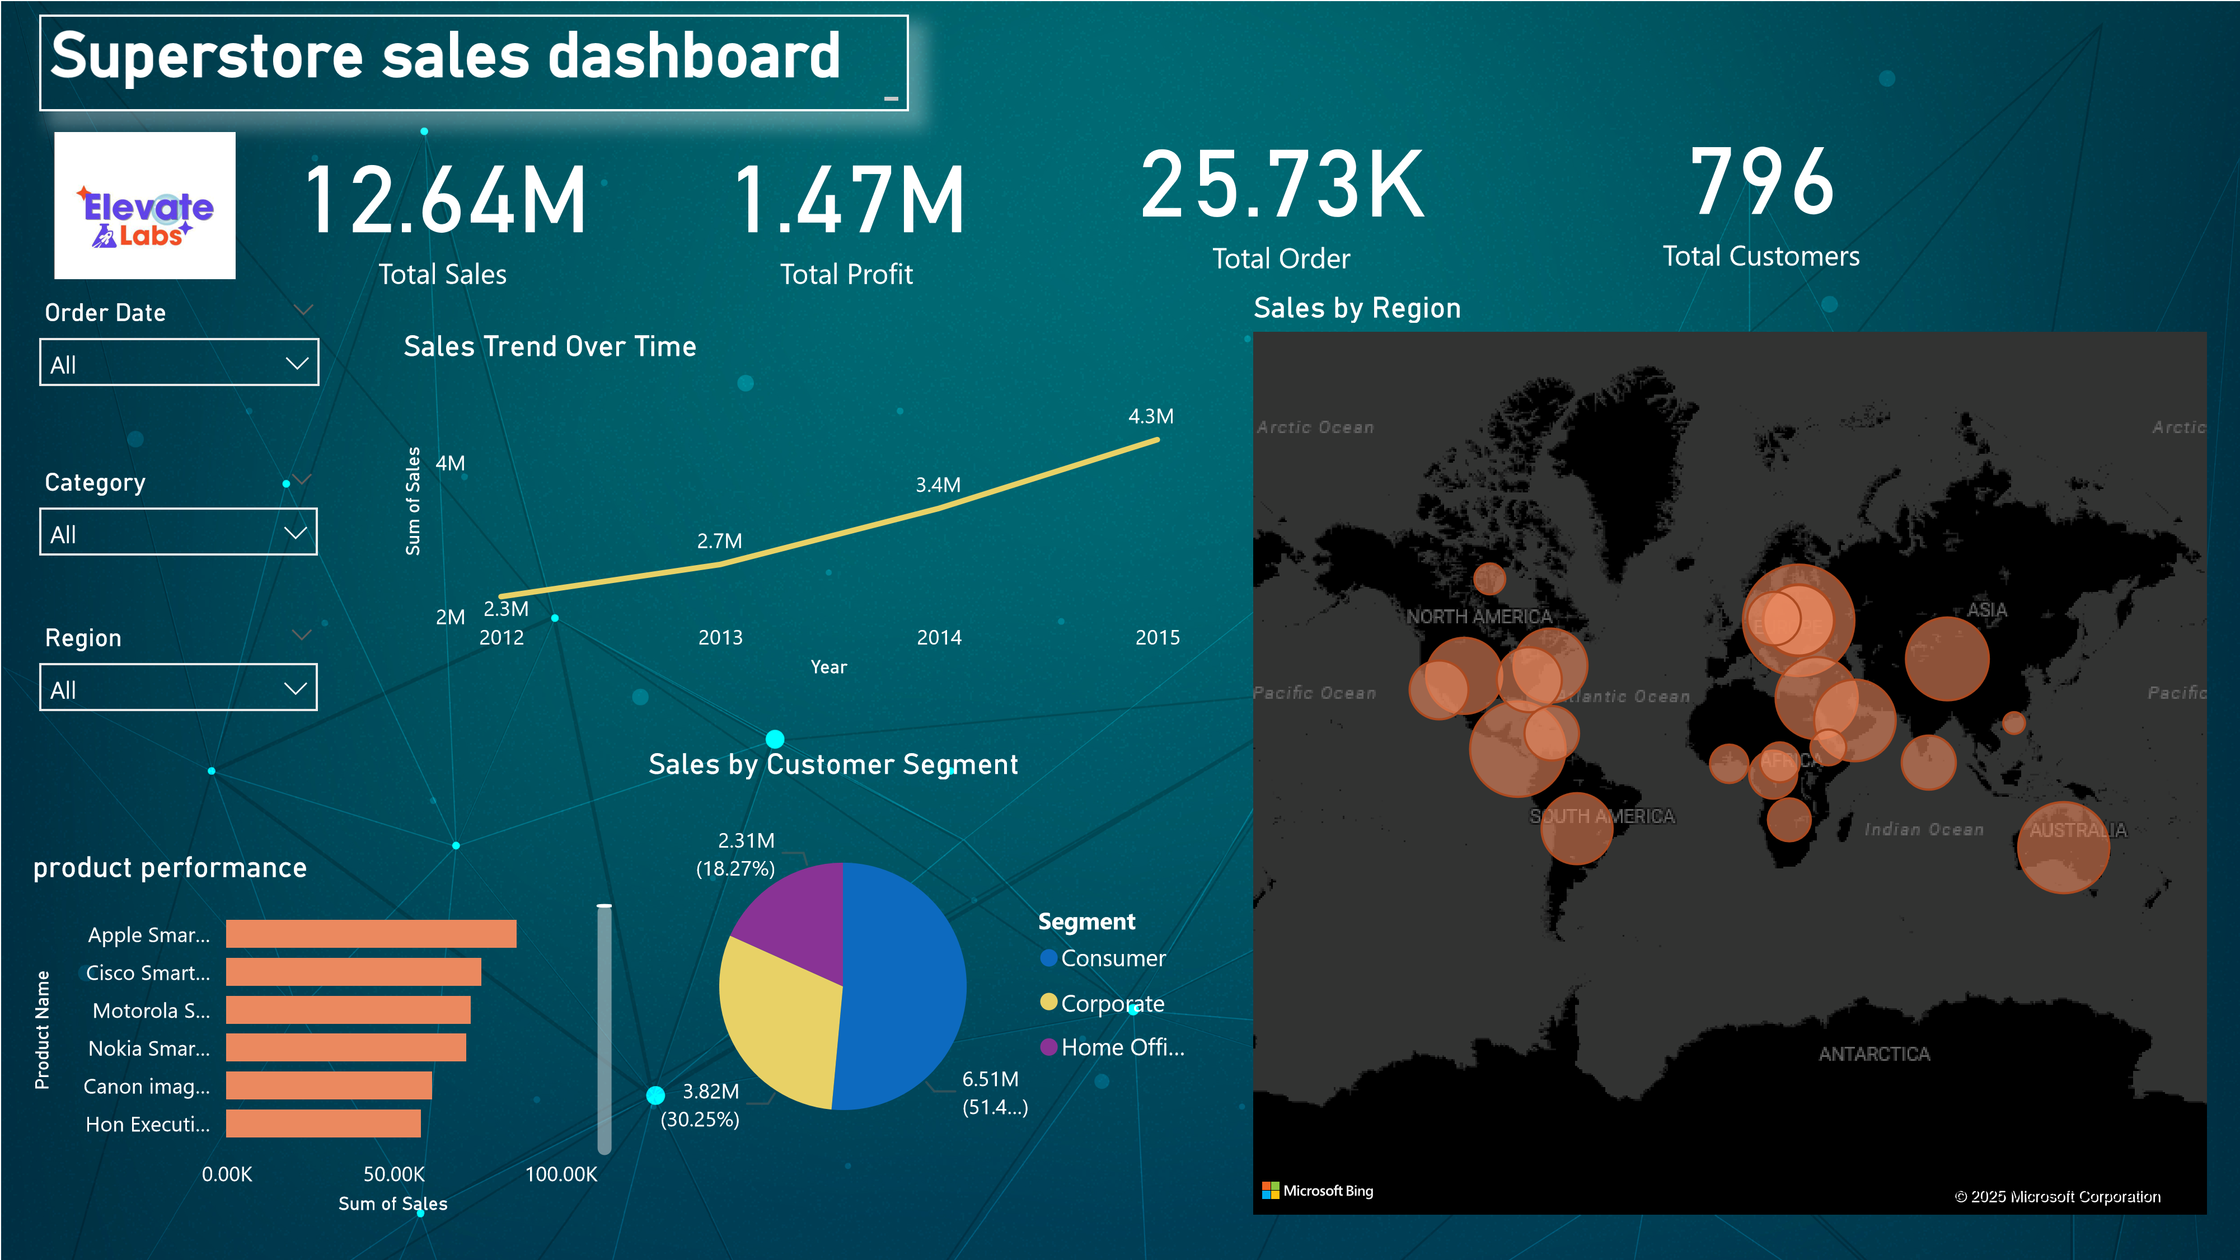

Power BI Desktop

📌

**Key Insights from Sales Dashboard**

✅

**Total Sales: $12.64M, with a steady growth trend from 2012 to 2015.**

✅

**Total Profit: $1.47M, indicating a healthy profit margin but potential areas for optimization.**

✅

**Customer Segments:**

•

**Consumer segment contributes the highest sales (51.4%).**

•

**Corporate and Home Office segments need targeted strategies for higher conversions.**

•

✅

**Regional Performance:**

•

**North America & Asia have the highest sales volume, as shown in the bubble map.**

•

**Regions with low sales need better market penetration strategies.**

•

✅

**Top Products:**

•

**Apple Smart Devices & Cisco Smart Equipment lead sales.**

•

**Some product categories show lower revenue, requiring a revised pricing or promotion strategy.**

🚀

**Recommended Business Actions**

📍

**Focus on High-Profit Segments:**

•

**Expand marketing efforts towards the Consumer segment, which drives the most revenue.**

•

**Offer exclusive deals & premium services to Corporate clients to increase their engagement.**

📍

**Improve Low-Performing Regions:**

•

**Launch targeted regional promotions where sales are low.**

•

**Partner with local distributors to improve accessibility.**

📍

**Optimize Product Strategy:**

•

**Invest more in high-selling categories like Smart Devices & Networking Equipment.**

•

**Apply discounts or bundle pricing to boost sales of low-performing items.**

📍

**Enhance Customer Retention:**

•

**Use personalized offers based on purchase history.**